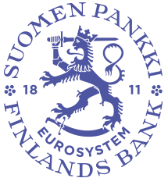

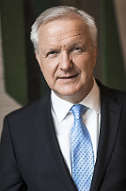
Olli Rehn’s calendar
Governor of the Bank of Finland
Member of the ECB Governing Council

March 2024

Date | Event | Place
1 March | Attendance at the inauguration of the President of the Republic of Finland | Helsinki
4 March | “The development of the EU over the next few years” roundtable, opening address | BoF
6-7 March | ECB Governing Council | Frankfurt
11 March | Bank for International Settlements (BIS) | Basel
13 March | ECB Governing Council | online meeting
13 March | Meeting with Minister of Finance Riikka Purra  ‘Latest economic and financial developments’ | BoF
13 March | Meeting with media | BoF
13 March | Speech (in Finnish): ’Economic outlook in Europe and Finland and monetary policy’, economics alumni | Bank of Finland Museum
14 March | Speech (in Finnish): ’Do we still value working together to solve the country’s economic problems?’, jubilee seminar organised by the Guarantee Foundation | Helsinki
14 March | Speech (in Finnish): ‘Economic outlook in Europe and Finland and monetary policy’, government night session | Helsinki
15 March | Speech (in Finnish): ’Economic outlook in Europe and Finland and monetary policy’, Governor event for stakeholders | BoF
15 March | Meeting with Eero Heinäluoma, Member of the European Parliament  ’Latest economic and financial developments’ | BoF
16 March | Meeting with media | Helsinki
18 March | Lecture (in Finnish): ’Monetary policy in the euro area’, course in Finnish and euro area economic policy, University of Helsinki | Helsinki
20 March | Meeting with Annika Saarikko, Leader of the Centre Party  ’Latest economic and financial developments’ | BoF
21 March | ECB General Council | Frankfurt
21 March | General Board of the European Systemic Risk Board (ESRB) | Frankfurt
22 March | Parliamentary Supervisory Council | BoF
22 March | Meeting with media | Helsinki

Details of topics and participants provided where applicable.

